UML Diagram for Bulletin board App

1 Class Diagram
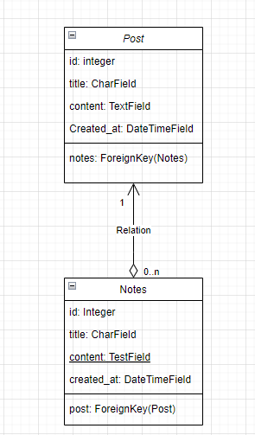

2. Use case Diagram

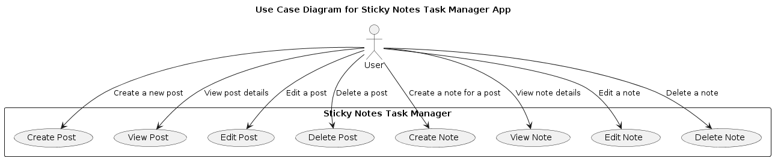

3. Sequence Diagram

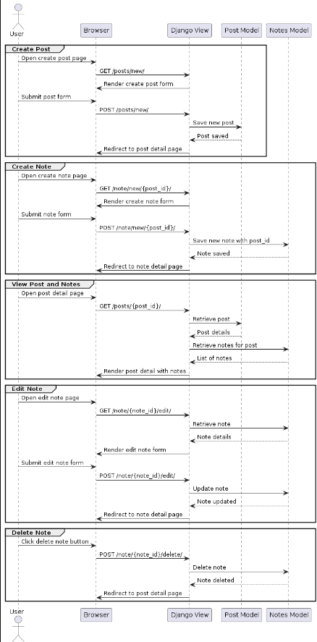

4. CRUD Matrix Diagram

Entity | Create | Read | Update | Delete
Post | X | X | X | X
Notes | X | X | X | X

